**RESOURCEFULL MOCK 2019**

**Uganda Advanced Certificate of Education**

**GEOGRAPHY P250/3**

**MARKING GUIDE**

**STANDARDS**

Examiners are guided by the following standards.

1. Marking is by impression unless otherwise stated.
2. Candidates should exhibit ability to discuss and illustrate the points raised, with relevant local examples.
3. A mere outline of points should not get more than half of the marks allocated for that section.

**AWARDS**

23 – 23 – Excellent answer

18 – 22 – A very good answer

15 – 17 – A good answer

12 – 14 – An average answer

8 – 11 – An “O” level answer

1 – 7 – a fail answer

00 – totally irrelevant

**SECTION A: FIELD WORK**

1. (a) i) Candidates are expected to state a topic of study, clearly showing **WHAT** was studied and **WHERE** the study took place. The topic stated should also bear a **geographical relationship**.  **(2 mks)**

(ii) Candidates should come up with clearly stated objectives. The objectives should be

* Measurable
* Achievable
* Independent
* Specific
* They should be stated using the following measurable phrases.
* To find out ……
* To identify ….
* To assess …..
* To examine …….
* To discover …..
* The objectives should not be a mere repetition of the topic and any objective not related to the topic is **INVALID**

**(Any 4 valid x 1 = 4 mks)**

(b) Candidates are expected to identify the methods used to collect the information and how each method was used. As a rough guide to examiners, follow the formula of “I.D.I.D) that is;

I – Identify the method

D – Definition of the method = 1 mark

I - Illustration of the method = 1 mark 3 marks

D - Data presentation = 1 mark

**For example**

**OBSERVATION**

This is a method that involves the use of the naked eyes/ sense of seeing to see and interpret geographical facts in the field. By the use of my /our eyes, i/we saw ……. (attach data collected using the eye)

**INTERVIEWING**

This is a method that involves direct dialogue between the researcher and the respondent. Or it is a method that involves direct oral questions from the researcher and receiving direct oral answers from the respondent. By the use of our months/ we orally asked ………… (attach name of the respondent, question asked and data obtained).

**QUESTIONNAIRE**

This is a method that involves drafting questions on a piece of paper/ an e-mail which are then sent to the respondent who answers them and sends back the responses. We / I drafted a set of questions on a piece of paper that was sent to….. (attach name of the person, nature of questions sent and answers obtained)

**SAMPLING**

This is a method that involves obtaining part of the whole to represent the aspects under study.

Candidates should go a head to explain how samples were obtained on either interviews or samples on specific items found in the field like; soil, tea, etc and data obtained.

**RECORDING**

This is a method that involves noting. jotting down data either in form of notes, illustrations or diagrams. By the use of our/ my pen and paper we noted down …… (attach data recorded)

**MEASUREMENT**

This is a method that involves obtaining length, weight, height, distance of the specific items in the field. By the use of (examples, weighing scale, tape measure, metre rule, foot ruler) attach relevant data collected. **Any 3 methods x 3 = 9 marks)**

(c) Candidates should clearly show how land use activities/ human activities have impacted (either positively or negatively on the physical surroundings for example;

* Impact of agriculture on soil /vegetation.
* Impact of mining on soil/vegetation
* Impact of brick making on drainage
* Impact of road construction on relief.

***Example***

* Quarrying on the steep slopes of Mutundwe hill, West of the Nalukolongo market has led to de-vegetation.
* Brick making in the Kazinga lowland, East of the Nalukolongo market has led to the destruction of swampy vegetation.
* Construction of settlement on the top of Mutundwe hill has led to dereliction
* (destruction of the land scape)
* Industrial construction on the gentle slopes of Mutundwe hill, West of Nalukolongo market has led to the pollution of the Baziwe stream in the lowland.
* The planting of pine trees on the steep slopes of Mutundwe hill West of Nalukolongo market has controlled soil loss due to erosion etc.

(d) Candidates are expected to present the activities they carried out after the actual fieldwork. These may include;

* Presentation of group findings.
* Co-ordination of the gathered information
* Completion of diagrams and sketches.
* Compilation of the data
* Data analysis and interpretation
* Coming up with recommendations
* Compilation of a field report
* Dissemination of the field report.

The activities above should be phrased in past tense. Less than that, a candidate scores NO MARKS.

**Any 5 x 1 = 5 marks**

**(Total 25 marks)**

1. (a) (i) Candidates are expected to come up with a clearly stated topic indicating WHAT was studied, WHERE the study took place and a geographical relationship. **(2 marks)**

They should be stated using action phrases like;

* To find out……
* To discover……
* To identify…….
* To assess……
* To examine……. Etc

*objectives stated using the phrases below should not score any mark;

- To tell….

To know….

To understand…..

To elucidate……

**(Any 4 valid x 1 = 4 marks)**

(b) A panoramic sketch is a pictorial representation of physical and man-made features of the area under study as seen from a strategic view point.

*consider the following;

- Tittle (clearly showing WHAT, showing WHAT?) = 1 mk

- The view point = 1 mk

- Proper labeling of the features = 4 mks

* Enclosing frame = 1mk

*The shape of the panorama depends on the view point as below;

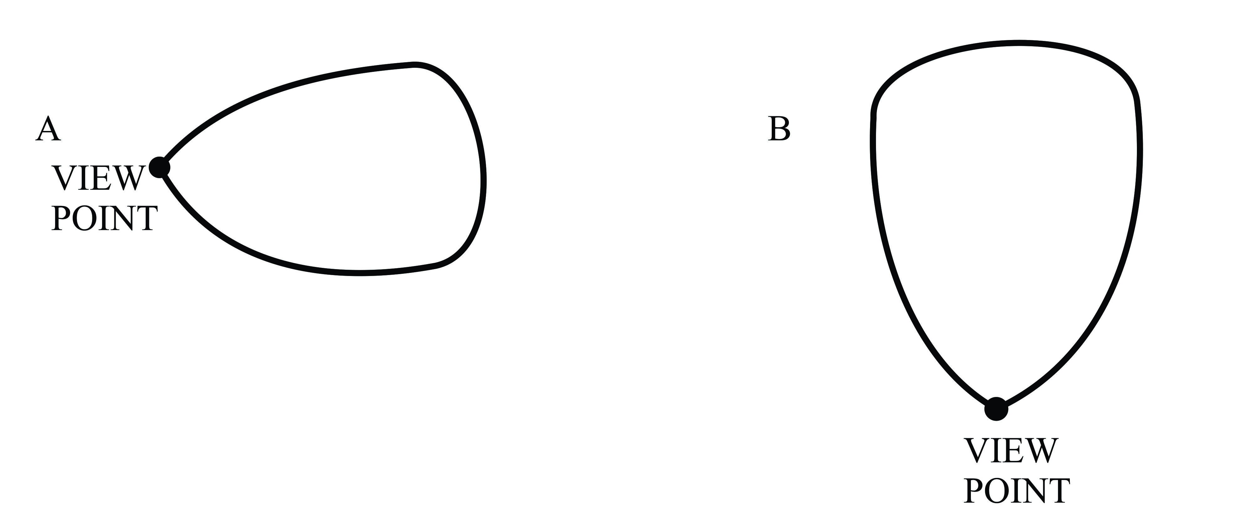

Note: - Physiographic regions = 02 mks

* + Settlement = 01 mk (Any 1)
  + Drainage features = 01 mk (Any 1)

(c) Candidates are expected to show how relief has influenced land use activities in the area studied. Therefore, points expected should be between;

* Relief and settlement
* Relief and transport
* Relief and telecommunication
* Relief and agriculture
* Relief and quarrying
* Relief and tree planting
* Relief and industrialization etc
* The raised points should be both positive and negative.
* The points should bear some form of accountability (why?)
* They should not be stated using……..influenced
* Accepted phrases include;
* Encouraged
* Favoured
* Discouraged
* Limited
* Hindered
* In giving accountability acceptable phrases include;

…………because of ………………….

………….due to ………………………

**(Any 6 x 1 = 6 marks)**

* Candidates are expected to show the problems they faced during the study problems should not be personal but geographical.
* Candidates should attach data missed because of the mentioned problem. Without this, candidates should score NO MARKS AT ALL.

**Problems expected;**

* Obstruction from tall trees and buildings.
* Unfavourable changes in weather, but not Climate
* Noise from machines. Over speeding vehicles
* Speedy respondents
* language/communication barriers
* Muddy environment
* Long distances travelled
* Faulty/ absolute measurement devices

**(Any 6 x 1 = 06 marks)**

**Total 25 marks**

**SECTION B: UGANDA**

1. To what extent was Volcanicity responsible for lakes formation in Uganda?

* Candidates are expected to define a lake
* They should identify the major lakes in Uganda.
* They should draw a sketch map to show the distribution of lake sin Uganda.
* In the body, an explanation of how volcanicity led to the formation of lakes is expected.
* Candidates should clearly bring out other processes.
* A lake refers to a body of water contained within a basin permanently. In other words, it is a hollow/basin depression of considerable size occupied by permanent water, surrounded by land.
* Lakes in Uganda include, Victoria, Kyoga, Albert, Edward, George, Wamala. Bisina, Opeta, Mburo, Nabugabo, Kachina, Kwania, Kijanebalola, Bunyonyi, Mutanda, Katwe and several others.

**A SKETCHMAP OF UGANDA SHOWING THE DISTRIBUTION OF MAJOR LAKES.**

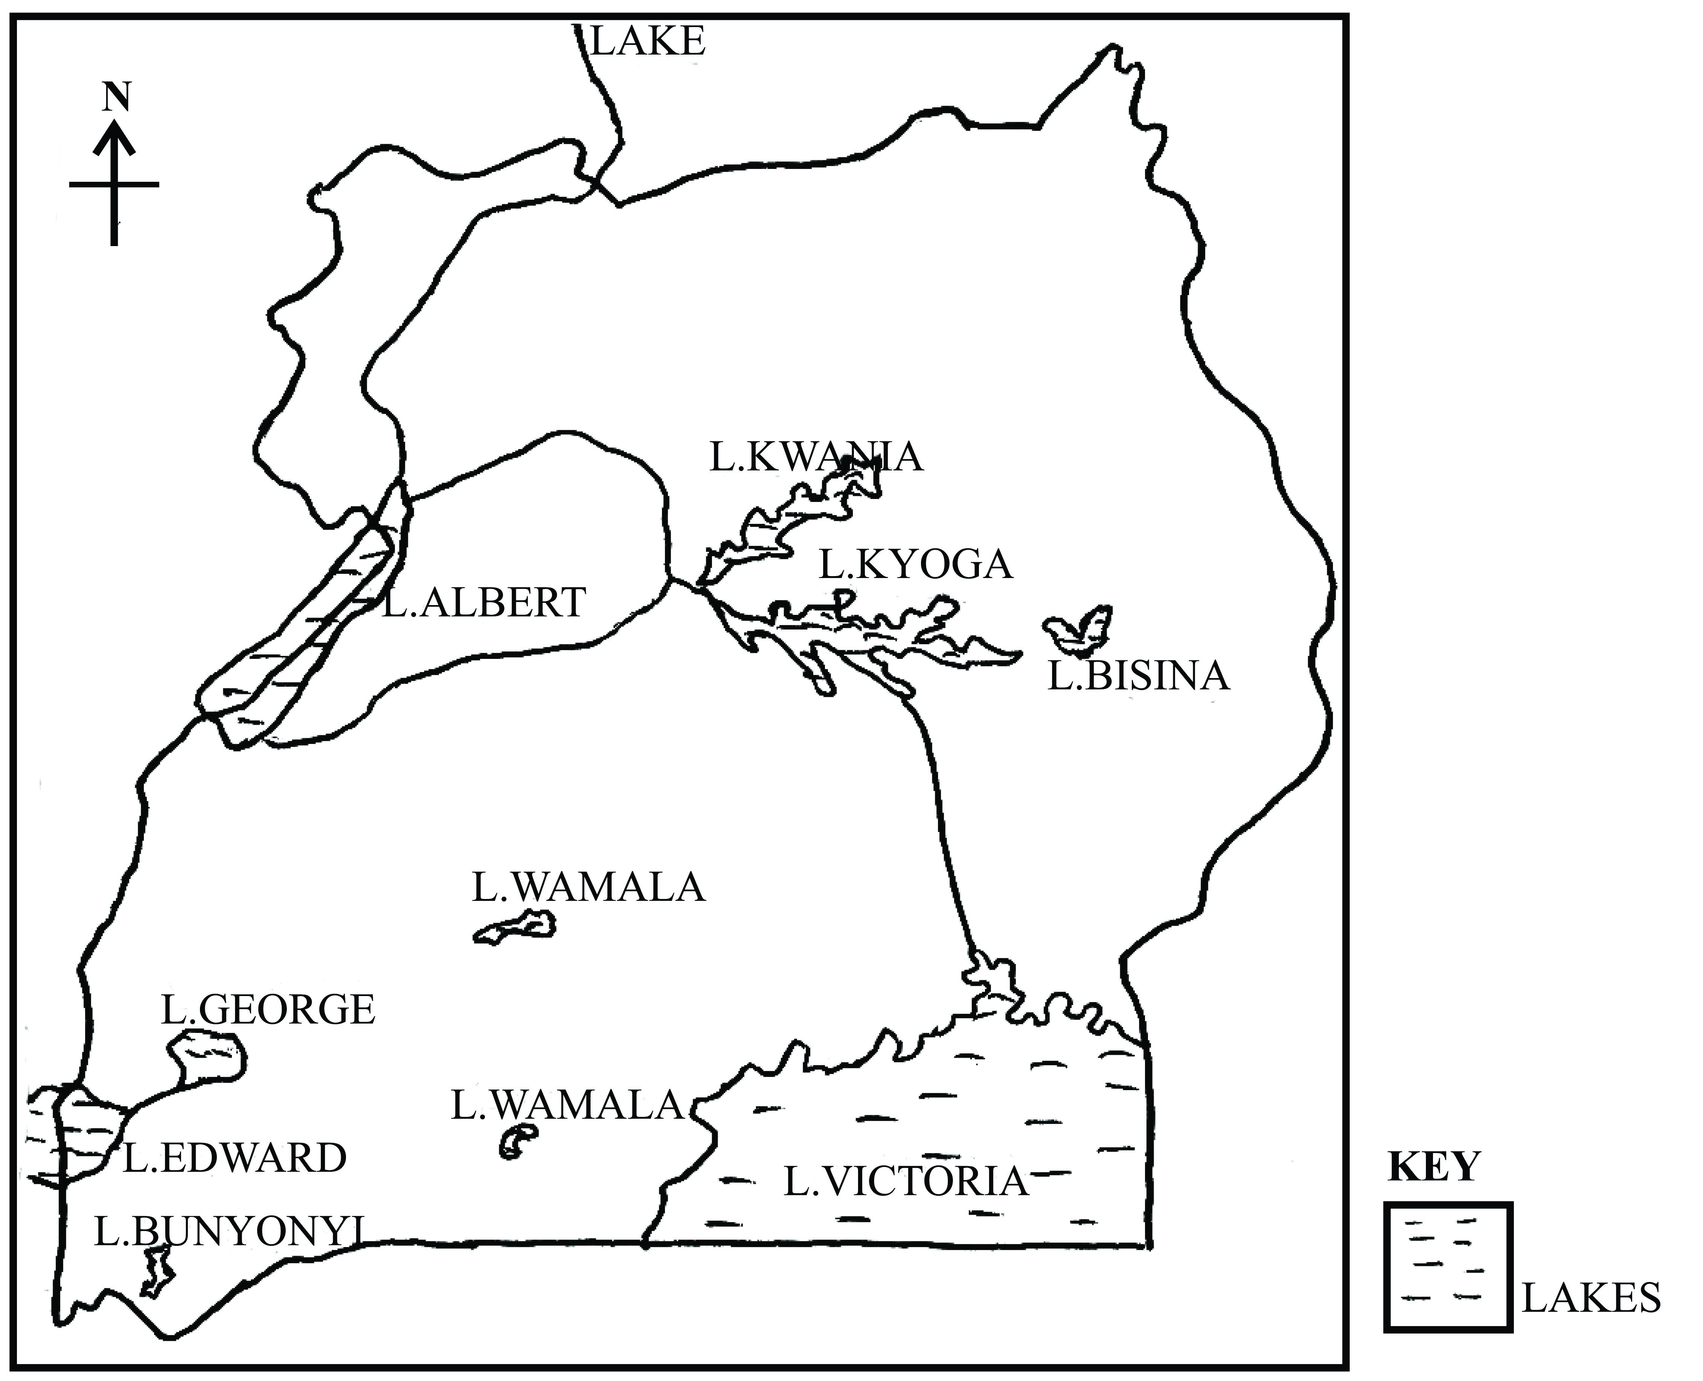

Note:

* Definition = 2 marks
* Identification = 2 marks 7 marks
* Sketch map = 3 marks

Volcanicity is defined as the total process through which motten material either in form of solids, liquid or gas are successfully ejected onto the surface of the earth. This process led to the formation of the following lakes.

**Explosion crater.**

These were formed as a result of gas explosions that blow off the surface of the Earth. It therefore resulted into the formationof shallow circular flat floored depressions surrounded by a low rim of pyrolasts.

Examples include; Lake Katwe, L. Nyungu, L. Kyamwiga, L. Rutoto, L. Munyanyange, L. Nkugute, L. Nyamusingire etc.

**Lava dammed lakes**

These were formed as a result of lava out flow that blocked a river valley. It forced the water to pond backwards thus forming a lake. Examples include; Lake Bunyonyi, L. Mutanda, L. Ndalaga, L. Mulehe and Muhondo in western Uganda.

**Caldera Lakes**

These were formed after the destruction of the upper part of the volcano through violent eruption. This comes as a result of acidic lave blocking the vent causing pressure to accumulate near the lave blockerage.

They are also formed through cauldron subsidence, where the upper part of the volcano subside to enlarge the crater.

**(3 x 2 = 6 marks)**

**Other processes include the following;**

* Down warping that led to the formation of down warped lakes examples (Victoria, Kyoga, Mburo, Kachina, Wamala etc)
* Faulting that led to the formation of rift valley lakes (Grabens). Examples (albert, Edward and George)
* Glaciation. This led to the formation of;

1. Glacial erosional lakes/ Rock basin lakes like Lac du Speke, Lac du Noir, lac du Catherine etc.
2. Glacial depositional lakes/moraine dammed lakes.

* Deposition. This led to the formation of;

1. Ox-bow lakes found along r. Ruiz in Ankole
2. Lagoon lakes formed to long shore drift like Lake Nabugabo in Masaka.

* Solution lakes formed as a result of the erosion of soluble rock material to form hollows that are later filled with water. Example is lake Nyakasura in Fort Portal (Kabarole)
* Man’s influence / man made lakes. Deliberately dug up by men or indirectly formed due to dam construction.

Examples include; Kabaka’s lake in Ndeeba, Lake Kibimba in Eastern Uganda and Lake Kajjansi in Wakiso.

**6 x 2 = 12 marks**

**Total = 25 marks**

1. (a) Account for the destruction of Wetlands in Uganda today.
2. Explain the impact of Wetland destruction to Uganda.

* Candidates are expected to define the term ‘Wetlands’.
* They should identify the major types of Wetlands.
* A sketch map is expected to show Wetland distribution in Uganda.

**Definition**

* It refers to an ill-drained low lining area that can remain wet enough for plant species to grow even when there is no rainfall.
* It also refers to a poorly drained low lining area dominated by papyrus vegetation or other water loving plant species.
* On estimate, Wetlands cover 29,000km2 of land which is about 13% of Ugandan’s total land area.
* Wetlands are rapidly disappearing in Uganda mainly to climatic changes and the activities of man preferably, settlement, industrialization and agriculture.
* Wetlands in Uganda are categorized into;

1. Lacustrine Wetlands which are found on lake shore lines like, Lutembe swamp in Wakiso, Nabugabo swamp in Masaka, Nabajuzi swamp in Masaka, Masese – Kirinya swamp in Jinja, Mutai swamp in Jinja.
2. Riverine swamps which are found on the course of rivers like, River Mpologoma swamp, Senibwa swamp, Doho wetlands, mpamujuguWetland in Mubende, Kazinga channel wetland etc.
3. Dombos / open valley swamps like Nagombwa in Iganda Kiruruma in Kabale, Kerim –mgoro in Karamoja.

**A SKETCH MAP O FUGANDA SHOWING WETLAND DISTRIBUTION**

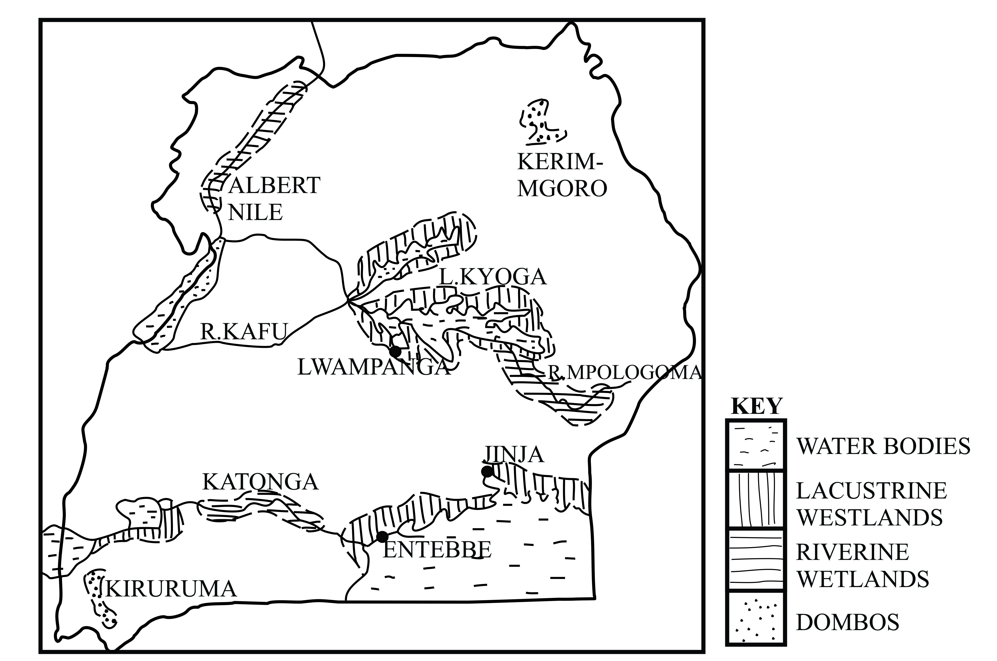

**Note:**

* Definition = 2 marks
* Identification + Examples = 3 marks 7 marks
* Sketch map = 2 marks

**Reasons for Wetland destruction**

* Continous harvesting of plant fibres for the art and craft industry like in the Mpolooma Wetland of Eastern Uganda, Nakayiba Wetland in Masaka, Busega Wetland in Kampala etc.
* The activity of industrialization e.gMbalala area in Mukono, Banda – Kyambogo Wetlands in Kampala, Namanve Wetland in Mukono, Masese – Kirinya Wetland etc.
* Increase in population which has increased demand of land for settlement e.gMutai Wetland in Jinja, Bwaise – Kalerwe Wetlands in Kampala, Kwempe Wetlands in Kampala, Nabajuzi and Nakayiba Wetlands in Masaka.
* The activity of agriculture especially the growing of water loving crops e.g Rice in the Lwera Wetland in Kalungu, Doho Wetlands in Butaleja, Kibimba Wetlands n Bugiri etc.
* The activity of road construction e.gSisa – Nakawuka Wetland in Wakiso for the Entebbe Express Highway, Namungoona – Lubigi wetlands for the Northern Byp[ass in Kampala.
* Mining of sand and clay inWetlands such as; Kajjansi in Wakiso, Kamonkoli in Mbale, Sekaza Wetland in Kakin –wakiso.
* Siltation from upland farming area e.g Muatai swamp in Jinja.
* The planting of environmentally unfriendly tree species (descanting trees) that take in a lot of water, hence making them dry e.g Eucalyptus in Lubigi swamp in Wakiso and Kamonkoli swamp in Mbale.
* Continuous disposal of garbage mainly in Wetlands surrounding Kampala by KCCA e.g in Kitezi swamp in Wakiso and Wakaliga Wetland in Kampala.
* Establishment of water pumping stations in wetlands which has lowered their water table e.g in Nabajuzi wetland in Masaka and Ggaba wetland for Kampala water.
* The construction of sports and recreation centres e.gWankulukuku wetland in Kampala, kaazi wetland in Wakiso, Lugogo sports Arena and Kyadondo Rugby grounds in Kampala.
* Political influence, where politicians sometimes offer “blank cheques” to residents to settle in wetlands e.g in the Nyamuliro wetland in Kabale and Kashambya wetland in Kabale for Irish potato growing.
* Allocation of land to veterans (former servants in the army) e.g in Wakaliga in Kampala, Luzira wetland in Kampala, Kinawataka wetland in Wakiso etc.

**(10 x 1 = 10 marks)**

(b). Impact of Wetland destruction to Uganda.

* Adverse climate change leading to scarcity of water and drought.
* Decline in water quality due to disappearance of water sieves to remove toxic wastes.
* Increased flooding leading to damage of property e.g in Luzira, Katwe, Kawempe – Nsooba, Kalerwe etc in Kampala.
* Reduction in fish stocks due to the destruction of breeding grounds for fish.
* Increased occurrence of water borne diseases and sanitation problems e.g cholera, dysentery, Diarrhea, in places like; Katwe, Kamwokya, Ndeeba in Kampala.
* Loss of ecological bio-diversity through the destructionof habitants for birds and animals e.g Lubigi in Kampala.
* Lowering the water table leading to scarcity of surface water affecting shallow wells and bore holes in Awoja wetland in Soroti and Lumbuye wetland in Iganga.
* Loss of soil fertility due to increasing agricultural activities in wetlands like Kibimba in Bugiri.
* Loss of important fishing areas leading to reduction in fish stocks e.g fish farms in Kajjansi (Wakiso)
* Increase in carbon content in the atmosphere leading to pollution and increase in global temperature.
* Destruction of important farming areas especially the water loving plants like; Rice and Yams.
* Loss of grazing land especially in Teso land (Awoja wetland and Nakasongola (Lwampanga wetland).
* Shortage of hand craft materials like; reeds, papyrus
* Damage to valuable medicinal plants e.g mondia – white (mulondo)

**(8 x 1 = 8 marks)**

**Total = 25 marks)**

1. (a) (i) Maize = 6130 x 100 = 61.6%

9944

(ii) Potatoes = 669 x 100 = 6.7% 02 marks

9944

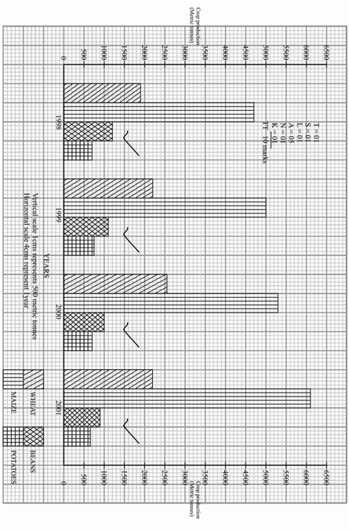

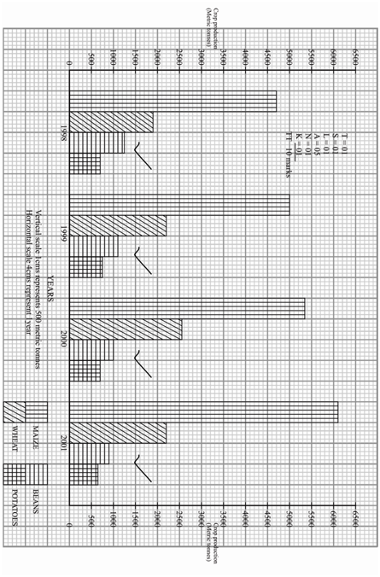

(c).Factors influencing belts in Uganda

* The climate elements especially rainfall and temperature
* The soil characteristics
* Influence of relief altitude
* The presence /absence of pests and diseases.
* Nature of the drainage in an area.
* Land ownership system (land tenure system)
* Capital availability
* Government influence
* Labour availability
* The level of science and technology
* Influence of people’s culture /traditions
* Historical factors
* Market availability
* Nature of the vegetation cover.

**(13 x 1 = 13 marks)**

**Total – 25 marks**

1. (a) Account for the low development of the power and energy sector in Uganda.

(b).Outline the current strategies towards sustainable development of the energy sector in Uganda.

* Candidates are expected to show the current status of the power and energy sector in Uganda.
* They should identify the various forms of power available in Uganda.
* A sketch map is expected showing the distribution of the different forms of power.

**Current status**

* Almost 92% of the energy used in Uganda comes from Wood (Blomass) either in form of wood or charcoal.
* 7% of the energy is imported petroleum and 1% from electricity.
* On estimate, 6-7% of the house holds are electrified, though worse off for rural areas where only between 1 – 2% are electrified.
* The current generated HEP capacity is estimated at 810 MW of which 25- MW comes from Bujagaali, 180MW from Nalubaale and 200 from Kiira power stations.
* Work is currently going on at the Karuma dam whose generatonis targeted at 600MW.
* Mini- hydro HEP stations are widely spread e.g Ishiba dam, Ayago dam, Nyagak dam, Kitagata, Bugoye, mpanga and Ishasha.
* Thermal generation estimated at 170MW is generated at Namanve, Tororo and Kiira thermal plants.
* Other potential forms of power have not yet been fully exploited e.g Geo – thermal energy from hot springs

**There are various forms of power in Uganda and these include;**

* Wood fuel from forests like Mabira, Budongo, Bugoma.
* Petroleum energy (mainly imported) used in mainly cities like; Kampala, Jinja, Arua, Masaka, Mbale etc. Local petroleum is undergoing exploration in Buliisa and Hoima.
* Abundant Solar energy.
* Wind energy mainly used in Moroto, Kotido, Kaabong, Abim, Nakapiripitetc
* Biogas in form of Cow dung from live stock.
* Liquid petroleum gas (LPG) from shell, Total, Kobil, Hass, city oil and other companies.
* Thermal energy generated at Namanve, Tororo and Kiira Thermal energy plants.
* Plenty of hydro electric power generated from the Nalubaale Kiira power stations, Bujagaali etc.

**A SKETCH MAP OF UGANDA SHOWING THE DISTRIBUTIONOF POWER RESOURCES.**

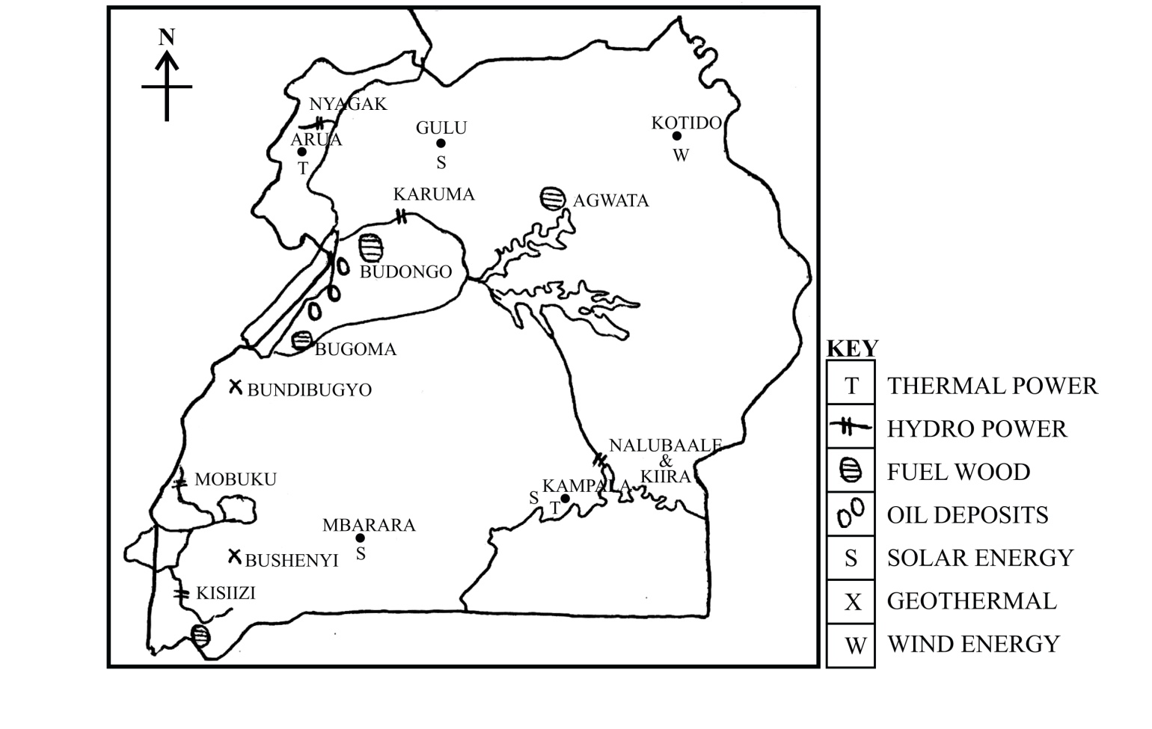

**Note:**

* Current status = 2 mks
* Identification = 3 mks
* A sketch map = 2 mks

**Reasons for the low development of power and energy**

* Fluctuation in water levels due to drought
* Shortage of capital to exploit some energy resources of the Sempaya hot springs in Bundibugyo.
* Under developed levels of technology which has led to the collapse of Wind mills in Moroto.
* Limited supply of skilled man power like engineers, geologists etc.
* Encroachment of gazette forests leading to their depletion e.g forests in Kalanagala for palm oil growing.
* Corruption in government offices e.g the flopped deal between government and the AES Nile power in Bujagali.
* Occurrence of political instability e.g the APF rebels which had severe effects on power generation in Western Uganda.
* Remoteness of some areas in form of steep relief and low lying areas.
* Conflicts with environmentalists that has frequently blocked investment into power e.g Bujagali.
* Theft o f power and illegal connections leading to power losses.
* Low households income leading to limited power connections.
* Impact of colonial treaties that regulated power supply e.g with Kenya and Egypt over theuseof the Victoria power.
* Wastage of power at domestic level e.g lighting during day water heating in bathrooms.
* The use of high energy consuming gadgets e.g 100 watts bulbs, outdated computers and fridges etc.
* Thefty of transmission wires and transformers to make clothing hangers, TV, Antenas, forge coins etc.
* Wreckage/damage to pipelines e.g the Mombasa – Kisumu oil pipeline.
* Some dams have exceeded their life expecting e.g Nalubaale dam.

**8 x 1 = 8 marks**

**(b). Current strategies to develop power and energy**

* Government has obtained funds to be invested in the establishment of new power damse.g the on-going work on Karuma, Isimba dams and Anyayo North.
* Introduction of power saving gadgets e,g energy saver bulbs supplied to families by government, energy saver stoves etc.
* Government has attracted individual foreign companies to invest in power e.g Agrekko and Jacobsen from Norway for thermal at Namanve and Tororo.
* Introducing power rationing (load shedding) to save power for priority areas like; Mulago hospital, Makerere University, Nsambya and Mengo hospital etc.
* Introducing alternative forms of power like liquid petroleum gas (LPG), solar energy, Biogas etc.
* Sensitizing Ugandans on power saving mechanisms by UMEME through newspaper, TVs and radio stations.
* NEMA in conjunction with the NFA has embarked on a plan to regazette all forests so as to limit forest depletion.
* Government has embarked on a plan of rural electrification to limit over dependency on forests.
* Govnermnt has massively investment in petroleum exploitation and exploitation in the Albertine belt.
* Government waved taxes and initial costs for power transmission and connection by domestic users.
* Operations against illegal connections have been done e.g through “operation sigma”
* Encouraging afforestation and re-afforestation programmes are encouraged like in Iganga, Rukungiri, Lira, Jinja etc.
* Liberation and privatization of the energy sector e.g foreign companies such as; Tallow oil, CNOOC from China have been commissioned.
* Government is fighting corruption for effective fund allocation e.g the office of the IGG and the PAC (Public accounts committee) in parliament.
* Ensuring peace and stability.
* Importation of modern technology e.g derricks for oil exploitation in Hoima and Buliisa.
* Training of man power e.g the presidential scientific scheme, Ugandans have been given scholarships in geology, geo-mapping and surveying.
* The introduction of pre-paid metres by UMEME to limit illegal connections

**(Any 10 x 1 = 10 mks)**

**Total = 25 marks)**

1. Assess the contribution of tourism to the economy of Uganda.

* Candidates are expected to show the current status of Ugandans tourism sector.
* They should identify the various tourist attractions available and draw a sketch map to show them

**Current status**

* The total number of visitors in Uganda has been increasing since 2010. Currently estimated at around 1,160,000 arrivals per year.
* Most tourists come from Western Europe, USA, Asia and African countries.
* The percentage contribution to the country’s GDP is on an increase estimated at about 8%. Revenue earnings today are to the tune of US$ 805 millions.
* A sizeable number of Uganda’s population is employed by the sector, providing over 450,000 jobs.
* The number of National parks has increased from 4 by 1980 to 10 as per now.
* Most tourist sites are still under developed and generally under utilized.
* Modern hotels to provide accommodation to visitors have been put in place in addition to renovation of the existing hotels like Mwea Safari Lodge in Kasese.

**The major tourist attractions include the following**

* Wildlife forms the leading attraction that includes both the flora and the fauna.
* The drainage features e.g L. Victoria, Kyoga, hot springs, water falls, coastal features etc.
* The tropical vegetation including dense tropical rain forests like Bwindi, Mabira, Budongo etc.
* The relief landscape features such as ; the rift valley, colvanic and block mountains, glacial features on Mt. Rwenzori etc.
* Archeological and historical sites e.g Namugongo martyr’s shrine, Nyeko rock paintings, Bigobyamugenyi in Ssembabule etc.
* Cultural attractions like, styles of dressing, dancing, ceremonies, dishes etc.

**A SKETCH MAP SHOWING THE MAJOR TOURIST ATTRACTIONS AND WILD LIFE CONSERVATION CNETRES.**

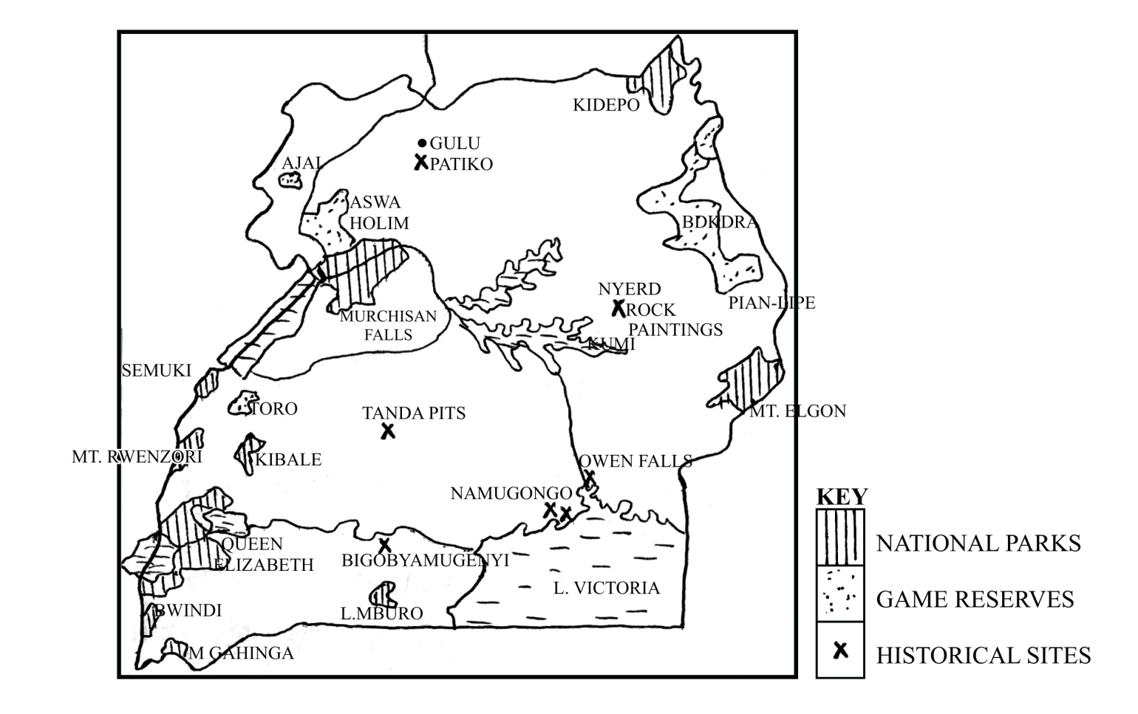

**Note:**

* Current status = 2 mks
* Identification = 3 mks 7 marks
* A sketch map – 2 mks

**Contributions of tourist to Uganda**

***Positives:***

* Generation of foreign exchange to Uganda.
* Source of employment to Ugandans
* Stimulated the growth of social infrastructures
* Stimulated the growth of economic infrastructure
* Promoted the conservation of nature and beauty.
* Promotes the preservation of cultures of people.
* Promoted the growth of local industries e.g pottery, crafts and photography.
* Source of market for local produce like food and art pieces.
* Promotes the growth of urban centres and towns.
* Development of internal relationships.
* Helps in the diversification of the economy.
* Promotes the use of the would be useless/ idle areas.
* Enable people to acquire some skills e.g hotel receptionists and language translators.

**(10 x 1 = 10 marks)**

**Negatives**

* Accelerates crimes and moral degeneration especially among the youths.
* Over exploitation of natural resources e.g swampy species to make art and craft material.
* Tarnishing the country’s image abroad
* Some tourists come in as spies of foreign countries and terror organs.
* Limiting other land use activities through conserving forests.
* Over population of animals leading to over grazing in national parks.
* Smuggling of endangered species to other countries like parrots and chimpanzees.
* Increase in prices of some local goods and bark clothes, art pieces.
* Fluctuation in revenue earnings due to seasonal increase and decrease in the visitors.
* Occasional degeneration of land/ environment especially where they camp for some days in bigger numbers.
* Profit repatriation since some foreigners have invested money in hotels for tourist e.g Madhvani group of Mwea Safari Hotel in Kasese.

**(8 x 1 = 8 mks**

**Total = 25 marks**

1. (a) Examine the current status of water transport in Uganda.

(b) Explain the steps being taken to develop the transport sector in Uganda.

**Current status**

* Uganda’s water transport is still underdeveloped and generally under utilized.
* The majorly used base for water transport are the lakes such as; Victoria and a few rivers such as the Nile.
* On such water bodies, both motorized and non-motorized vessels are used.
* Some water routes are served by road bridge ferries and other by wargon ferries.
* Most of the water transport operations are mainly by private owners of boats.
* There are few modern vessels in operation on Lake Victoria such as; MV Kalangala and MV Pamba owned by the govnerment through the Uganda Railways corporation.
* Most ports are still under developed e.gNakiwogo (Entebbe) Lwampanga (Nakasongola), Galiraaya (Kayunga), Laropi in West Nile etc.
* Water accidents are still very common which are usually destructive.
* Water routes still take a considerably small number of passangers compared to road transport.

**A SKETCH MAP OF UGANDA SHOWING MAJOR WATER ROUTES.**

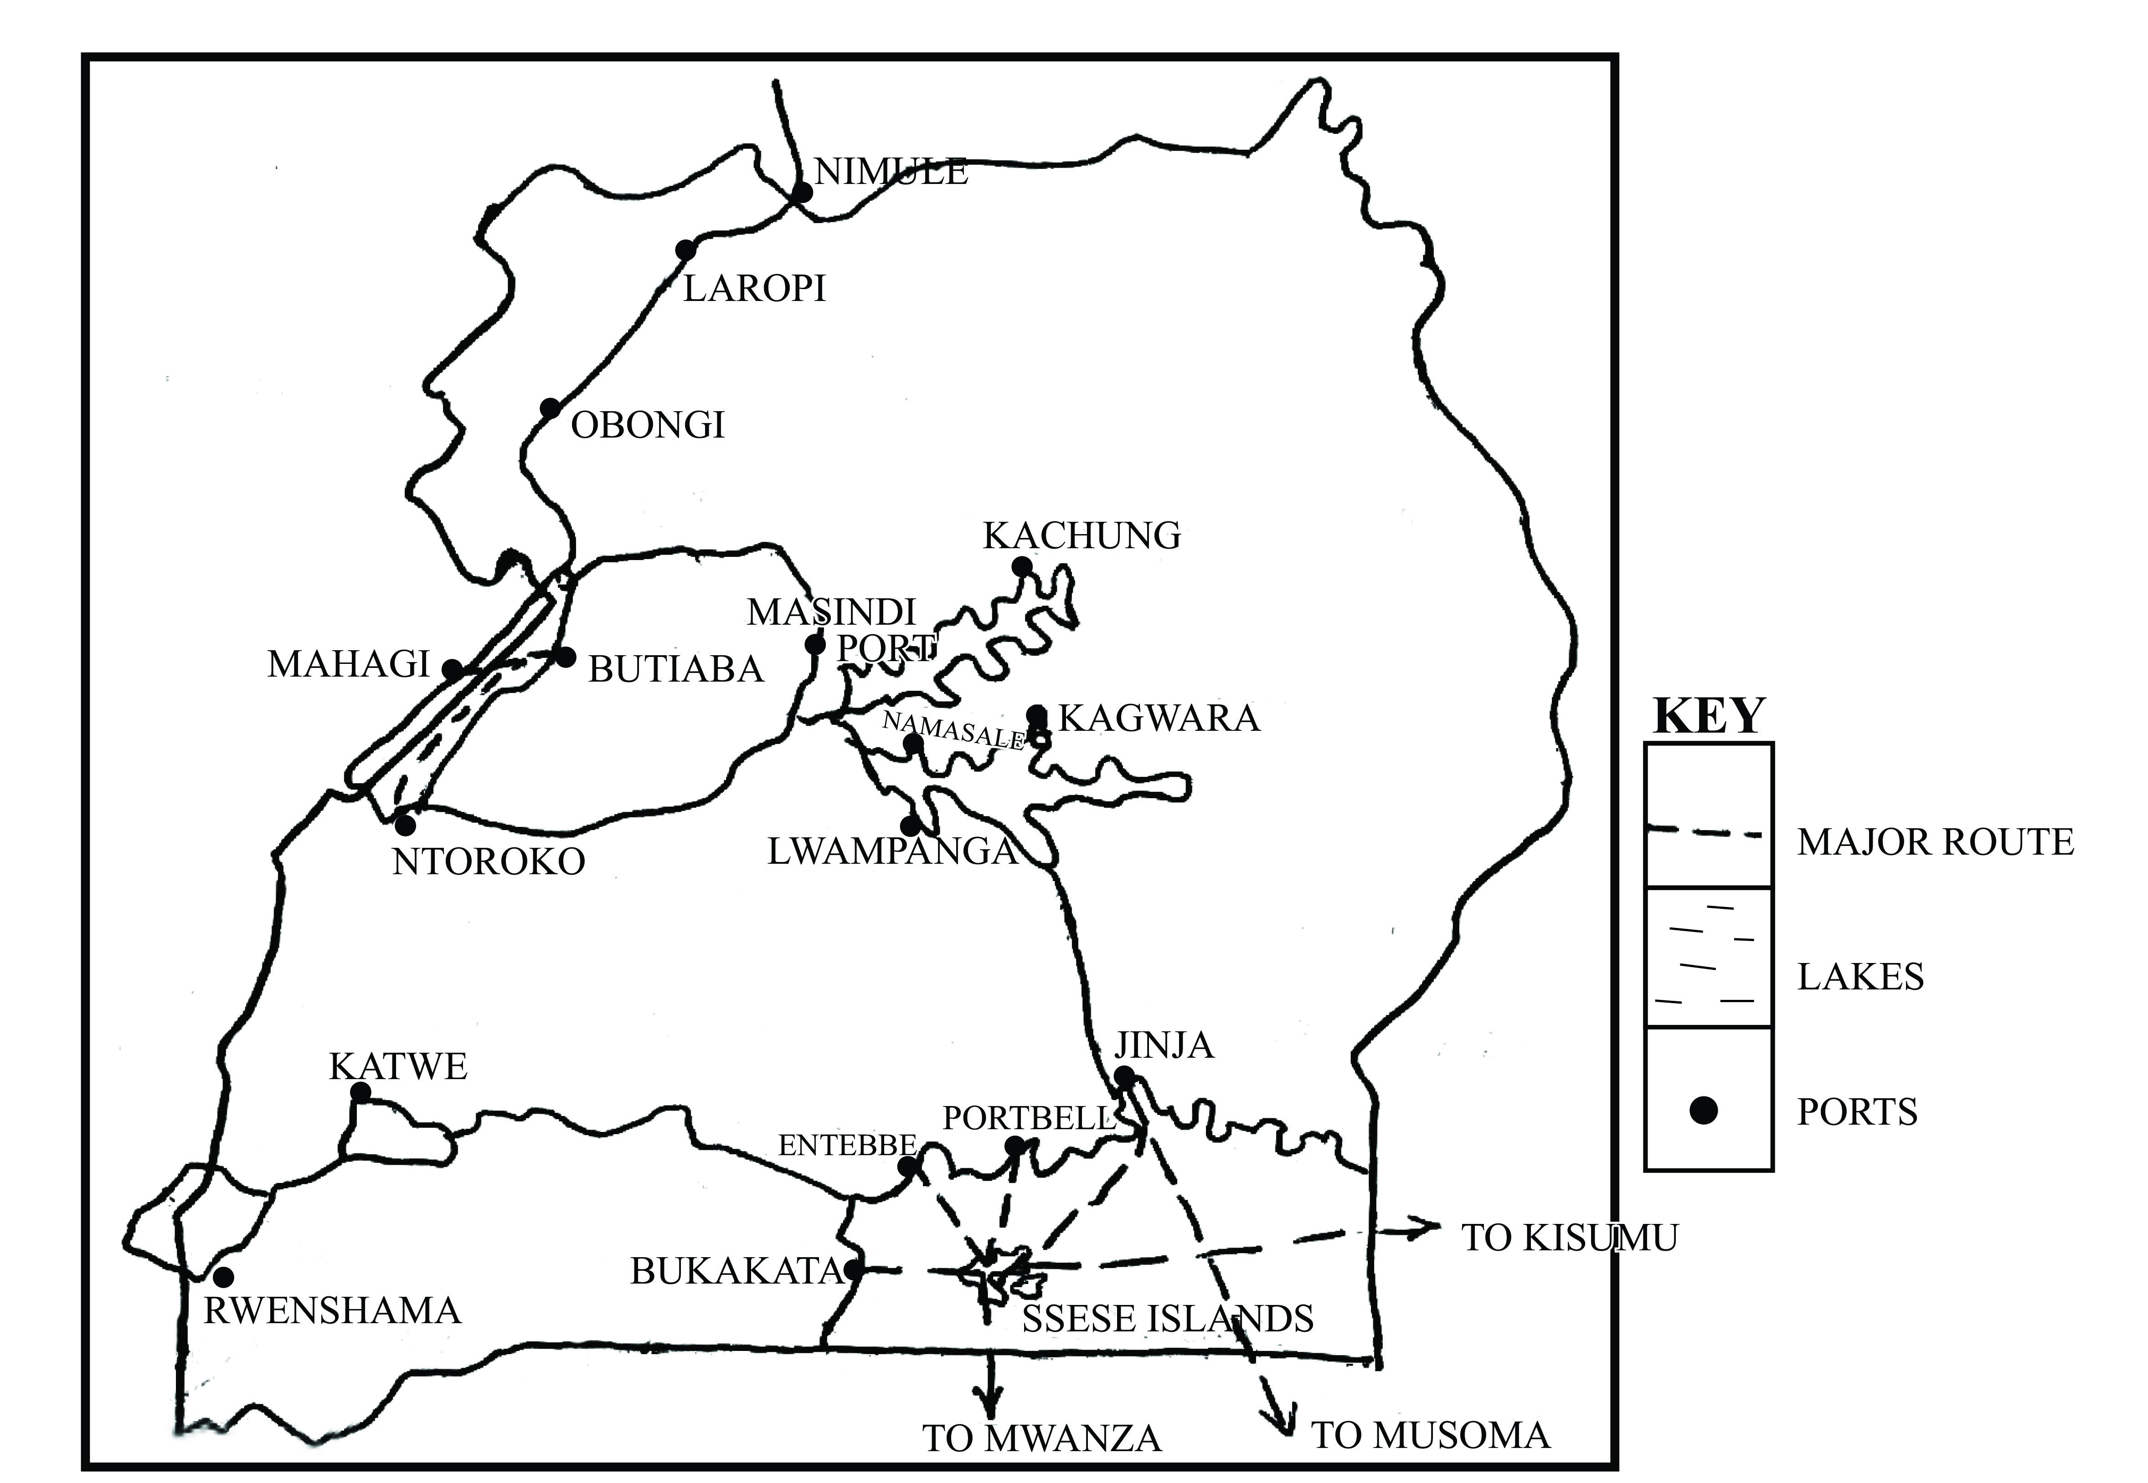

The major water routes include;

* Port bell – Kisumu on L. Victoria
* Port bell – Jinja on L. Victoria
* Jinja – Mwanza on L. Victoria
* Nakiwogo – Ssese on L. Victoria
* Portbell – Bukoba on L. Victoria
* Lwampanga – Namasale on L. Kyoga
* Bukungu – Ralle on L. Kyoga
* Masindi port – Namasale on L. Kyoga
* Kater – Rwensama on L. Edward
* Butiaba – Mahagi on L. Albert
* Butiaba – Ntorolo on L. Albert

**Note:**

* Current status any 6 facts x 1 = 6 marks
* Identification of routes = 2 marks 10 marks
* A sketch map of Uganda = 2 marks

(b) Steps being taken to develop the transport sector in Uganda.

* The ministry of works, transport and communication through the UNRA is constructing new roads as well as maintaining the existing one e.g the Entebbe Express Highway, Northern bypass etc.
* Foreign construction firms with skilled technocrats are being attracted e.g SIETCO from China, Spencon, CNOOC, CCCC, Arab contractors sterling etc.
* The ministry of works and transport I widening roads especially along black spot like corners e.g along the Kampala – Masaka road at Buddo – Nabbingo corner, Kampala Jinja road etc.
* Government has privatized /liberalized the transport industry e.g from UTC (Uganda Transport Company) to private owners of buses like YY coaches, Gaaga, Global coaches, Savannah coaches etc. MV Kalangala has been also privatized.
* There is training of man power in construction skills e.g civil engineers, supported by the Japanese government (JICA), Italy and Saudi Arabia.
* Machinery for road construction is extended to district level in form of tractors (graders) through the local government ministry.
* Government is acquiring loans from monetary agencies to finance the construction of transport network e,g from the Exim bank of China, WB ad the IMF.
* The Uganda police is deploying traffic officers along all highways to regulate vehicle speed and unlicensed drivers (operation Fika Salaama).
* The police and the army are deployed in politically insecure areas to fight against highway robbery e.g along the Kampala – Gulu highway.
* Patrol have been put on water by the UPDF to fight against pirates on water e.g on L. Victoria.
* Drivers are being organized into societies to manage the business e.g safe Boda by Bodaboda riders in Kampala.
* Traffic congestion is being worked upon through the installation of traffic lights, removal of most round about in Kampala and tarmacking the sub-roads connecting to highways.
* Construction of modern piers on landing sites/ ports e.g at Nakiwogo, Laropi, portbell etc.
* Introducing life saving jackets and gadgets to save people from water accidents.
* Expanding the Entebbe Airport and upgrading several aerodromes e.g Jinja, Soroti, Kasese etc.
* Introducing efficient water vessels on water bodies e.g the panyimur ferry on L. Albert, Kalangala ferry on L.Victoria etc.
* Carrying out game cropping (reloading fierce water animals) to gazette areas to save people from water accidents.
* Rehabilitating ports such as portbell and putting in place modern facilities.

**(15 x 1 = 15 marks)**

**Total = 25 marks**

**END**